|  |  |
| --- | --- |
| Team ID | PNT2022TMID07098  **Explore AS, differentiate** |
| Project Name | Project - Nutrition Assistance Application |
| Name | Safeena Thalath |
| Batch | B8-24AE |

**ASSIGNMENT 1**

|  |
| --- |
|  |
| **1. Create registration page in html with username, email and phone number and by using POST method display it in next html page.** |

The below program take data from registration form using POST method and display in next page

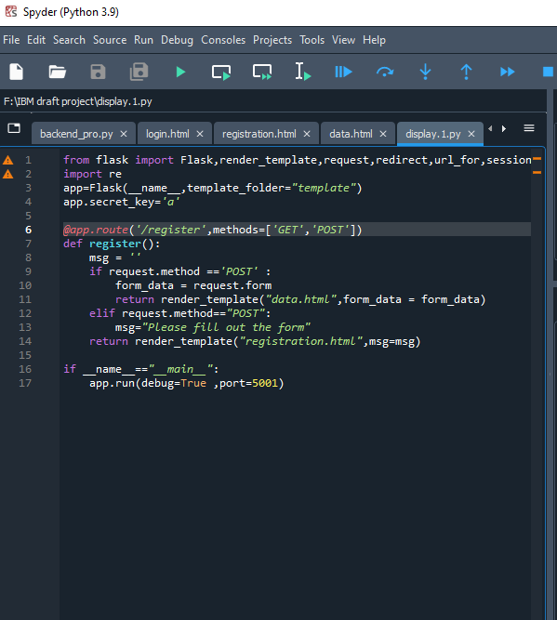

The below HTML code is used display data from registration

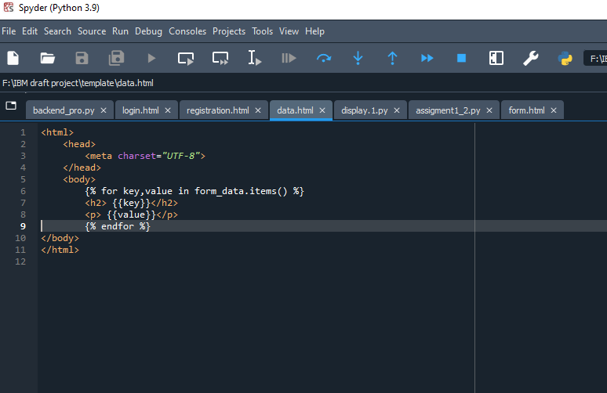

The below HTML code is for registration form

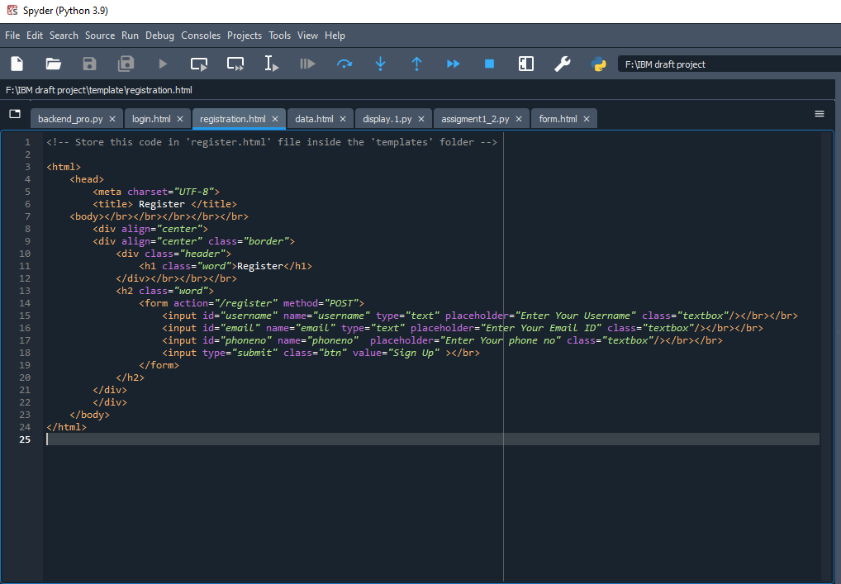

This is registration form

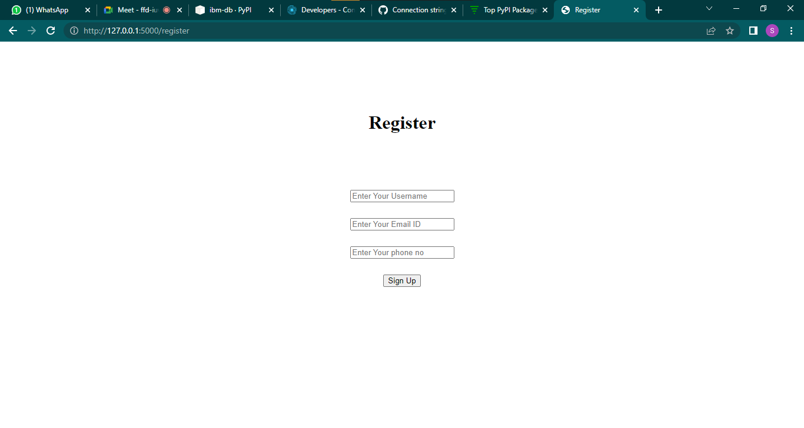

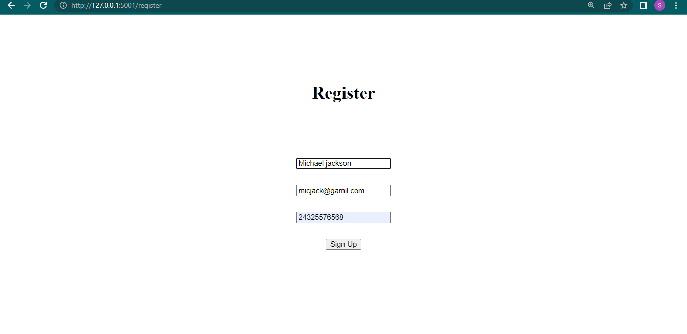

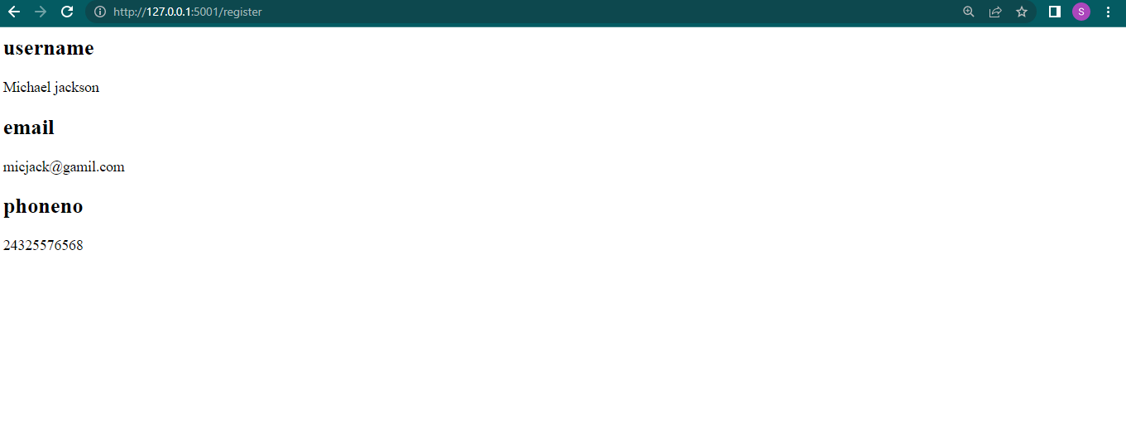

2. Develop a flask program which should contain at least 5 packages used from pypi.org.

The below program uses 5 packages from pypi namely flask,urllib,jinja,datetime and dateutil.

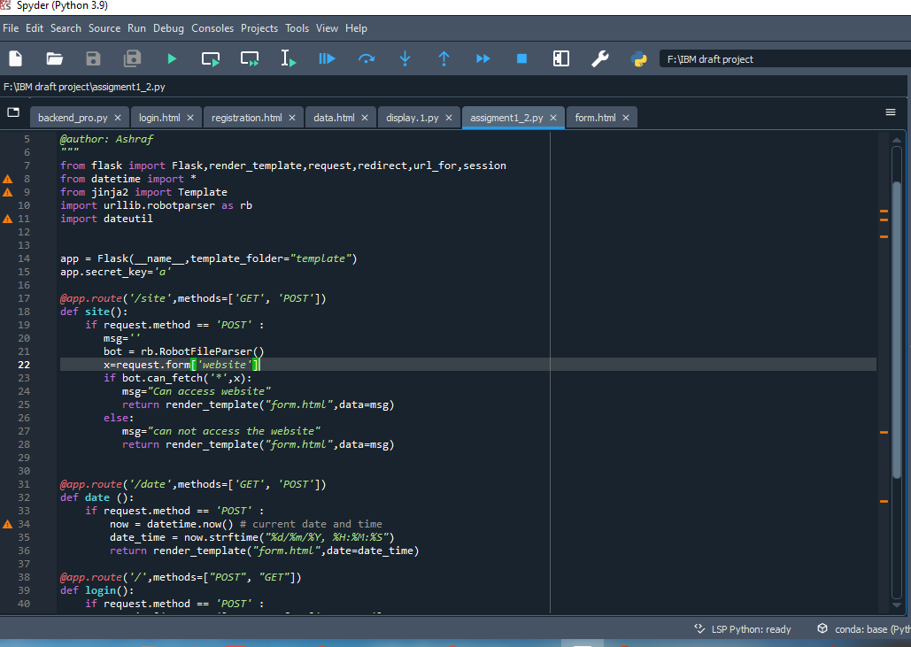

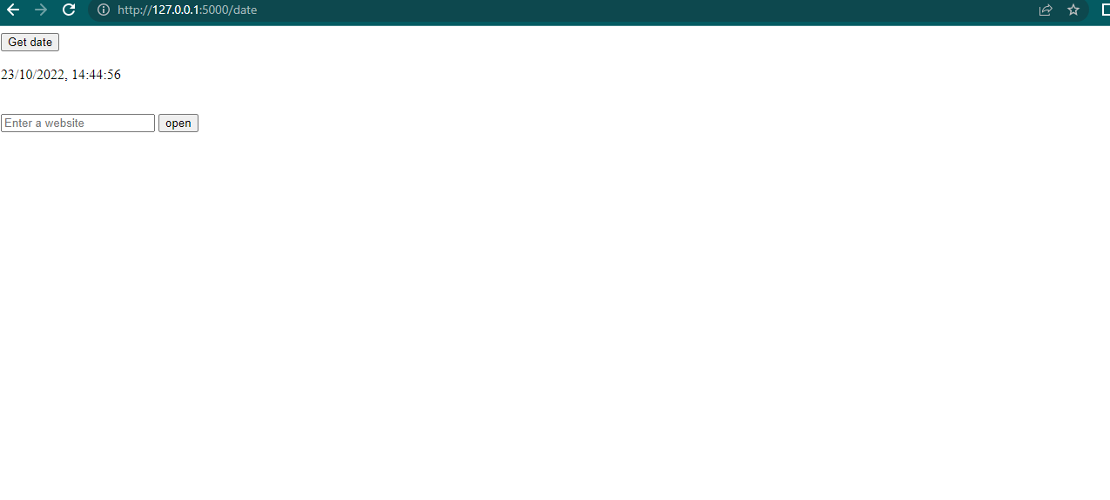The below “get date” button display the current time and date and check whether the user have access to the website given by user.

